

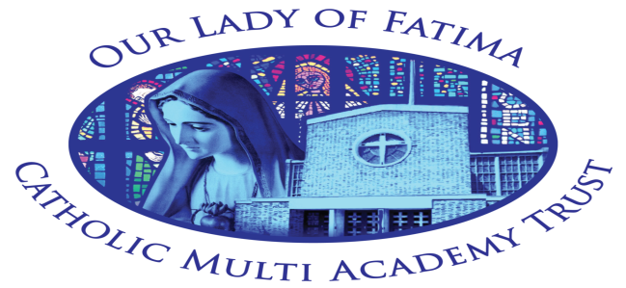
PRIVACY NOTICE – Job Applicants
for
Our Lady Of Fatima Multi Academy Trust

Privacy notice for job applicants
Under data protection law, individuals have a right to be informed about how the school uses any personal data we hold about them. We comply with this right by providing ‘privacy notices’ (sometimes called ‘fair processing notices’) to individuals where we are processing their personal data.
This privacy notice explains how we collect, store and use personal data about individuals applying for jobs at our school.
We, Our Lady of Fatima Catholic Multi Academy Trust, are the ‘data controller’ for the purposes of data protection law.
Our data protection officer is Natalie Pennells (see ‘Contact us’ below).
Successful candidates should refer to our privacy notice for the school workforce for information about how their personal data is collected, stored and used.
The personal data we hold
We process data relating to those applying to work at our Trust. Personal data that we may collect, use, store and share (when appropriate) about you includes, but is not restricted to:
- Contact details
- Copies of right to work documentation
- References
- Evidence of qualifications
- Employment records, including work history, job titles, training records and professional memberships
We may also collect, store and use information about you that falls into “special categories” of more sensitive personal data. This includes information about (where applicable):
- Race, ethnicity, religious beliefs, sexual orientation and political opinions
- Disability and access requirements

Why we use this data
The purpose of processing this data is to aid the recruitment process by:
- Enabling us to establish relevant experience and qualifications
- Facilitating safe recruitment, as part of our safeguarding obligations towards pupils
- Enabling equalities monitoring
- Ensuring that appropriate access arrangements can be provided for candidates that require them

Our lawful basis for using this data
We only collect and use personal information about you when the law allows us to. Most commonly, we use it where we need to:
- Comply with a legal obligation
- Carry out a task in the public interest
Less commonly, we may also use personal information about you where:
- You have given us consent to use it in a certain way
- We need to protect your vital interests (or someone else’s interests)
Where you have provided us with consent to use your data, you may withdraw this consent at any time. We will make this clear when requesting your consent, and explain how you go about withdrawing consent if you wish to do so.
Some of the reasons listed above for collecting and using personal information about you overlap, and there may be several grounds which justify the school’s use of your data.

Collecting this information
While the majority of the information we collect from you is mandatory, there is some information that you can choose whether or not to provide to us.

Whenever we seek to collect information from you, we make it clear whether you must provide this information (and if so, what the possible consequences are of not complying), or whether you have a choice.

How we store this data
Personal data we collect as part of the job application process is stored in line with The Information Management Toolkit for Schools document.
When it is no longer required, we will delete your information in accordance with the Information and Records Management Society’s toolkit for schools

Data sharing
We do not share information about you with any third party without your consent unless the law and our policies allow us to do so.
Where it is legally required, or necessary (and it complies with data protection law), we may share personal information about you with:
- Our local authority or Diocese– to meet our legal obligations to share certain information with it, such as shortlists of candidates for a headteacher position
- Suppliers and service providers – to enable them to provide the service we have contracted them for, such as HR and recruitment support
- Professional advisers and consultants
- Employment and recruitment agencies
Transferring data internationally
Where we transfer personal data to a country or territory outside the European Economic Area, we will do so in accordance with data protection law.

Your rights
How to access the personal information we hold about you
Individuals have a right to make a ‘subject access request’ to gain access to personal information that the school holds about them.
If you make a subject access request, and if we do hold information about you, we will:
- Give you a description of it
- Tell you why we are holding and processing it, and how long we will keep it for
- Explain where we got it from, if not from you
- Tell you who it has been, or will be, shared with
- Let you know whether any automated decision-making is being applied to the data, and any consequences of this
- Give you a copy of the information in an intelligible form
You may also have a right for your personal information to be transmitted electronically to another organisation in certain circumstances.
If you would like to make a request, please contact our data protection officer.

Your other rights regarding your data
Under data protection law, individuals have certain rights regarding how their personal data is used and kept safe. You have the right to:
- Object to the use of your personal data if it would cause, or is causing, damage or distress
- Prevent your data being used to send direct marketing
- Object to the use of your personal data for decisions being taken by automated means (by a computer or machine, rather than a person)
- In certain circumstances, have inaccurate personal data corrected, deleted or destroyed, or restrict processing
- Claim compensation for damages caused by a breach of the data protection regulations
To exercise any of these rights, please contact our data protection officer.

Complaints
We take any complaints about our collection and use of personal information very seriously.
If you think that our collection or use of personal information is unfair, misleading or inappropriate, or have any other concern about our data processing, please raise this with us in the first instance.
To make a complaint, please contact our data protection officer.
Alternatively, you can make a complaint to the Information Commissioner’s Office:
- Report a concern online at https://ico.org.uk/concerns/
- Call 0303 123 1113
- Or write to: Information Commissioner’s Office, Wycliffe House, Water Lane, Wilmslow, Cheshire, SK9 5A

Contact us
If you have any questions, concerns or would like more information about anything mentioned in this privacy notice, please contact our data protection officer:
- Natalie Pennells
Our Lady of Fatima Catholic Multi Academy Trust
First Avenue
Harlow
Essex, CM20 2NP
01279 425383

